Benedictus Alvian Sofjan

3035603095

COMP3230 Tutorial 3 Exercise 1

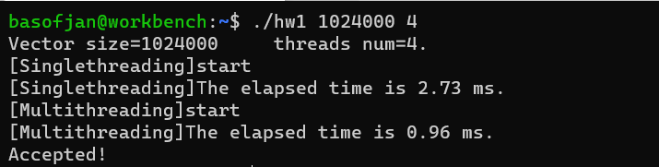Performance Evaluation

Speedup: 2.73 / 0.96 = 2.84375x faster